- Created Airbnb database in MongoDB ATLAS.
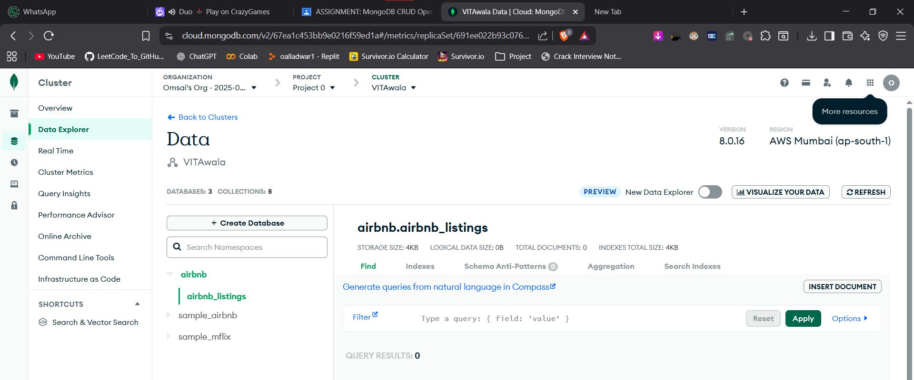

- Inserted 15 rows in the collection
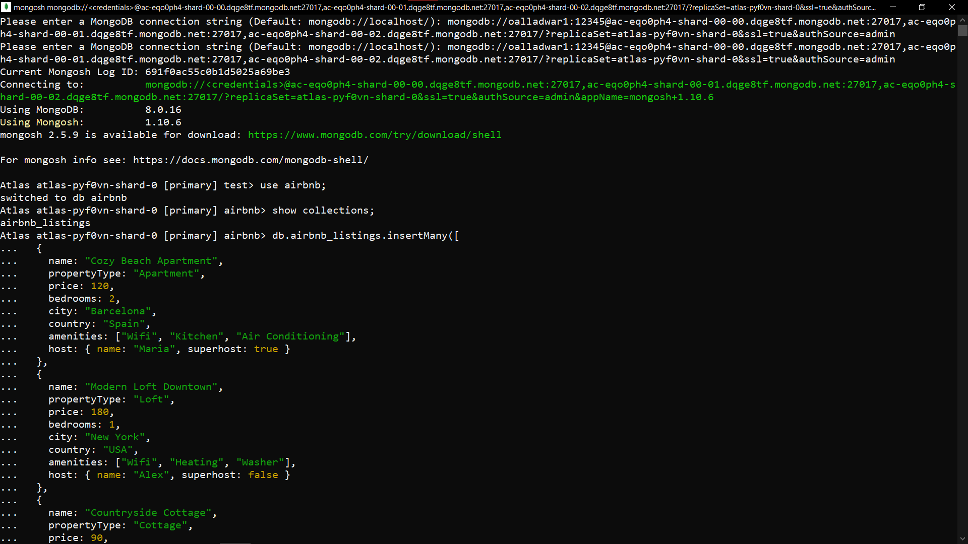
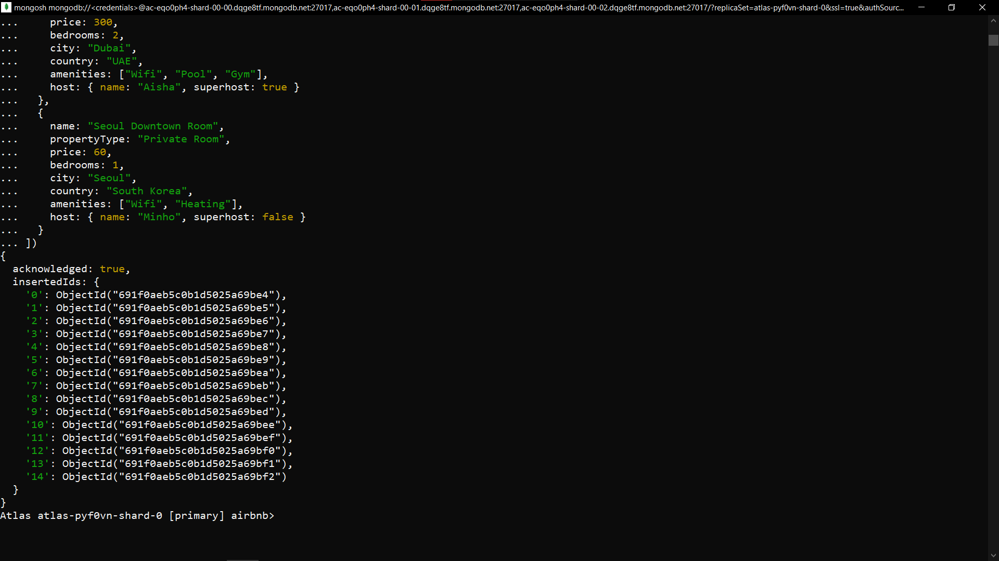

- Display any two documents from the collection.

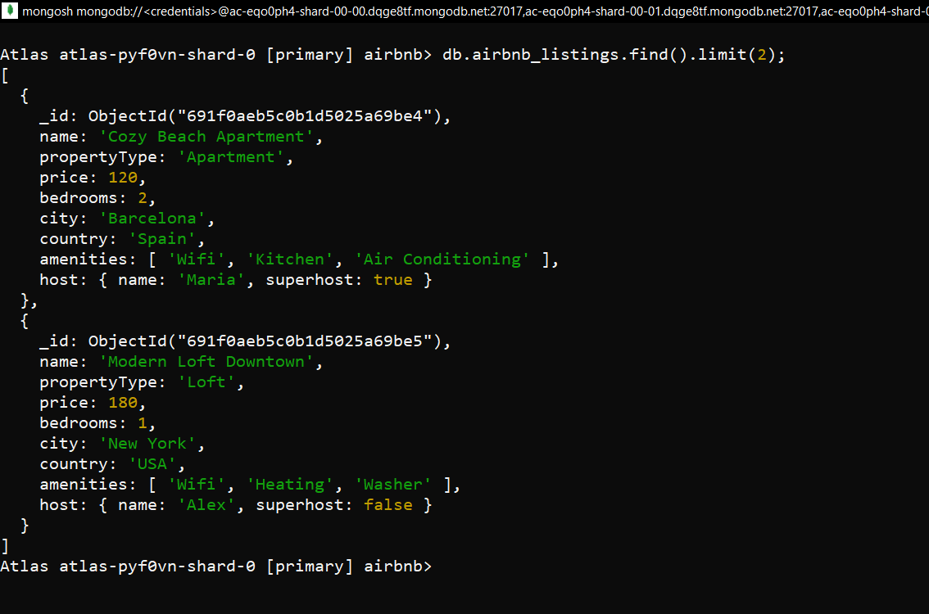

- Show all listings located in Barcelona.
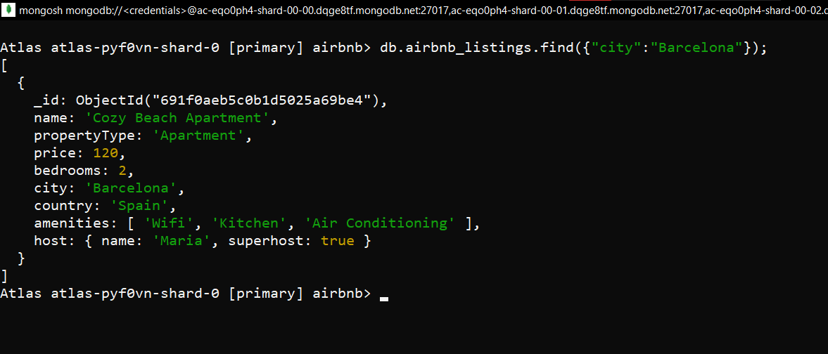

- Count how many listings are located in New York.
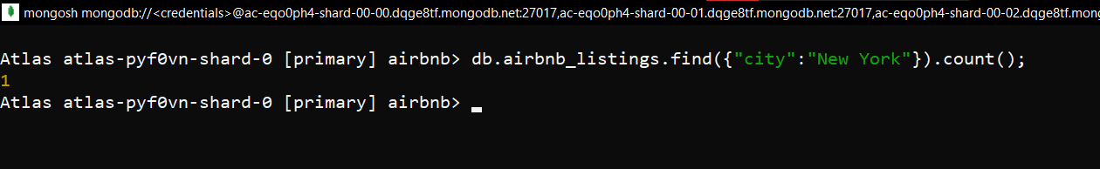

- Show only the name and propertyType of listings located in Paris.
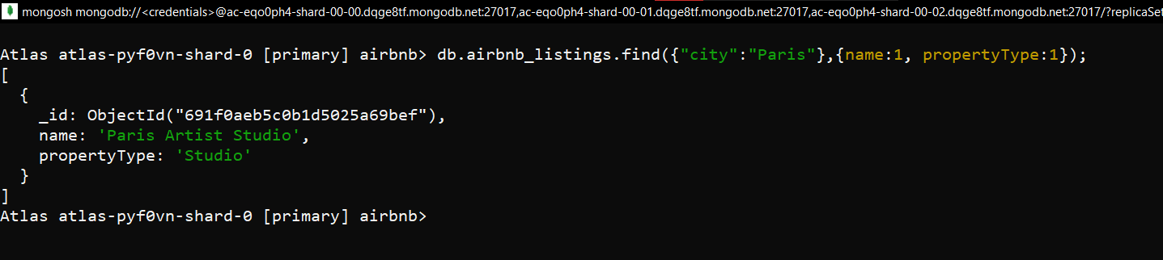

- Show all listings that have 3 or more bedrooms.
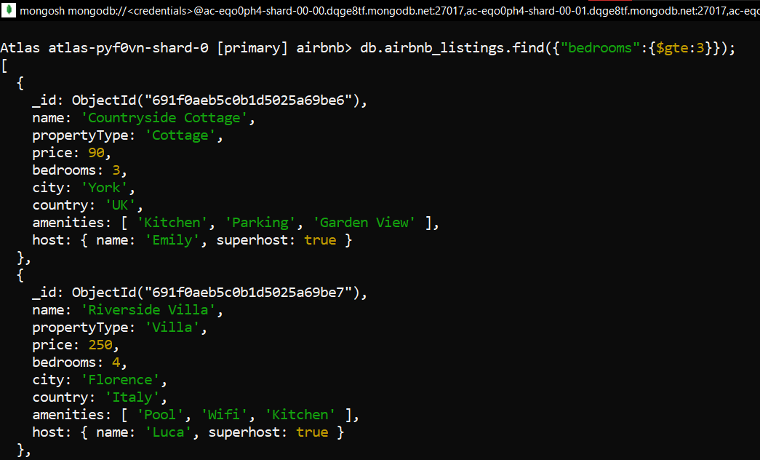
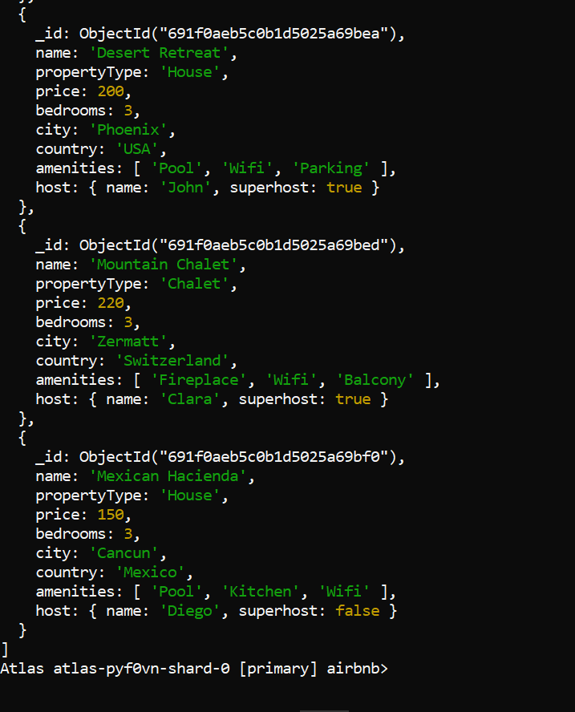

- Show all listings priced less than 100.
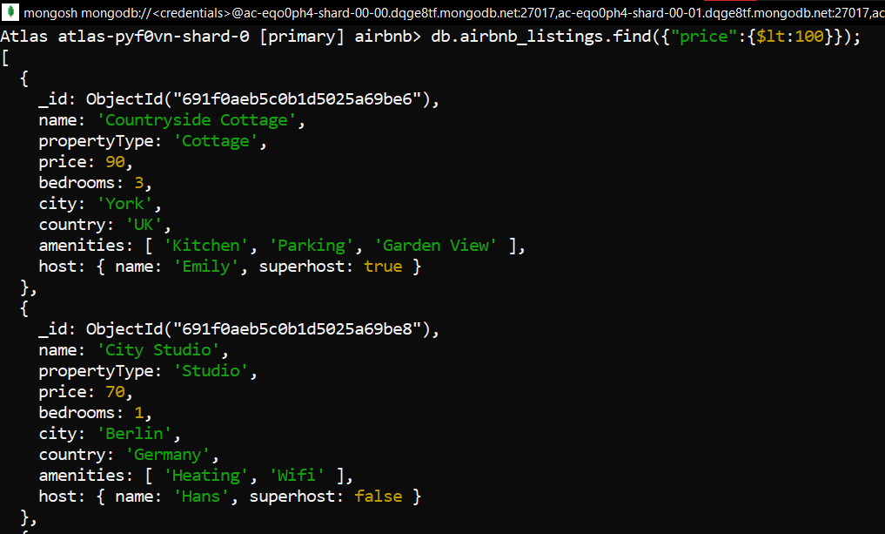
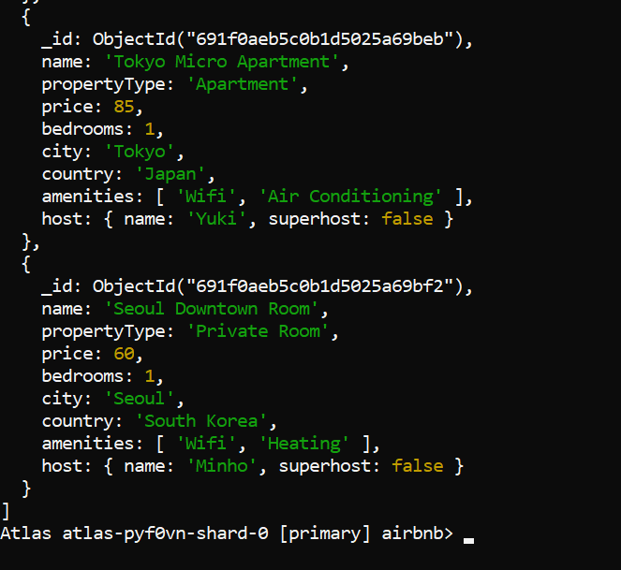

- Show all listings that include the amenity "Wifi".
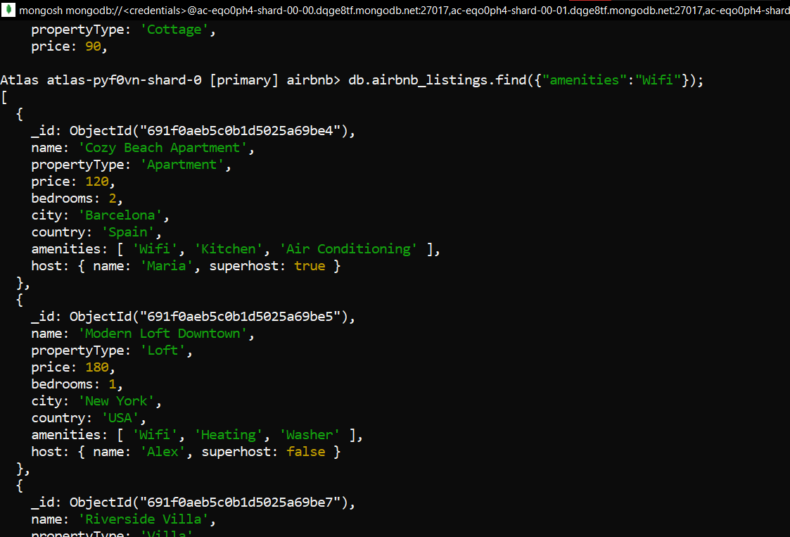

- Show listings that include ALL of these amenities:
o Wifi
o Kitchen
o Heating
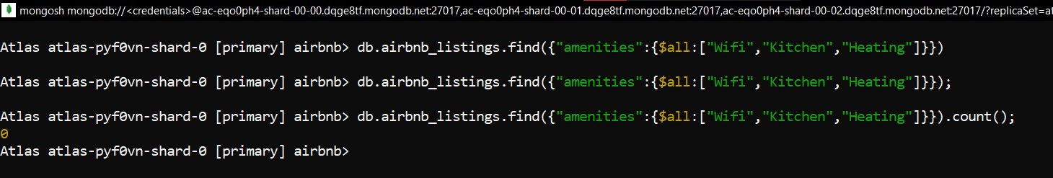

- Show listings where the first amenity is "Wifi".
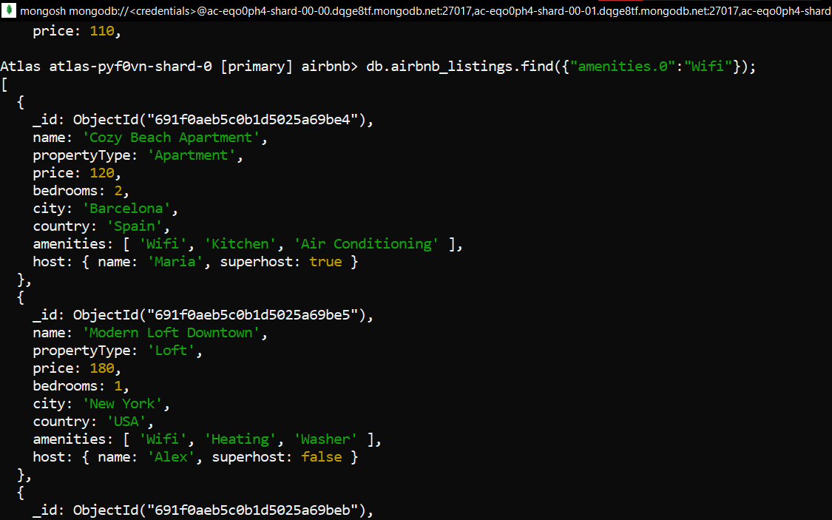

- Show all listings where the first reviewer's name is "Alice".
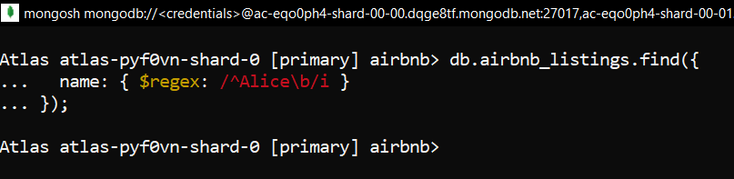

- Show listings that either:
o are located in London, OR
o have the amenity "Washer".

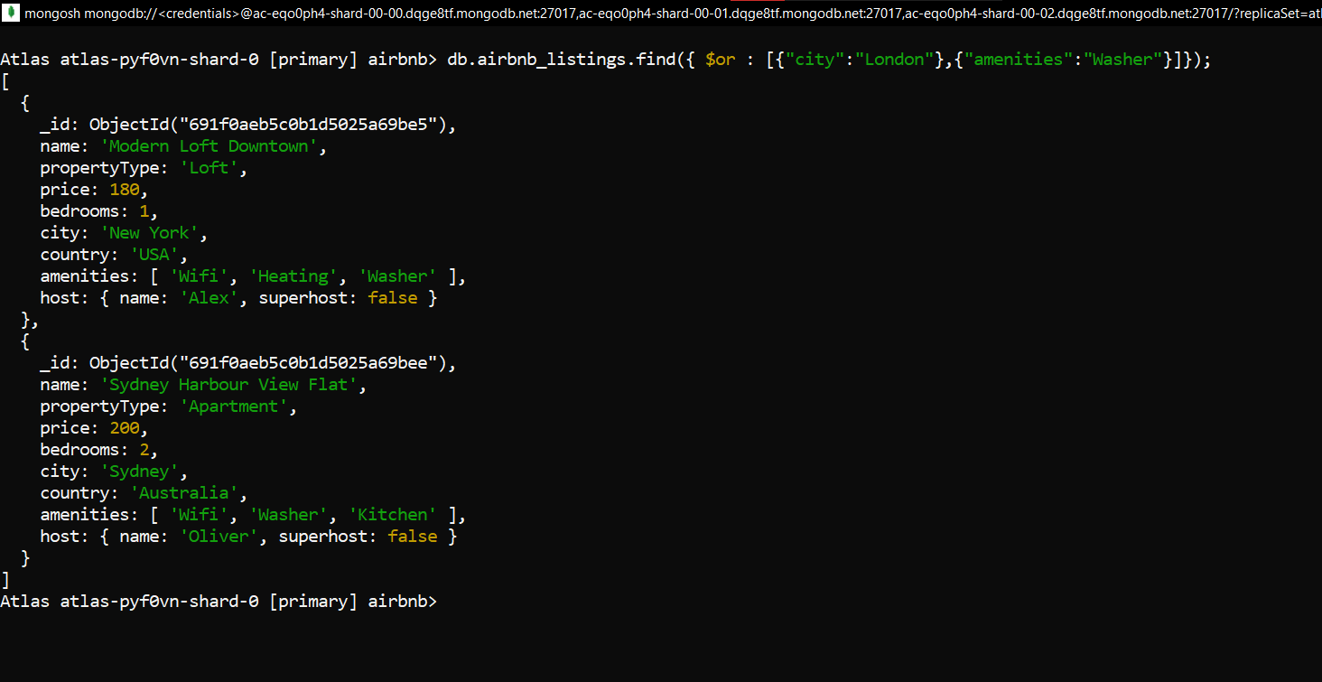

- Sort all listings by price (ascending) and show the first 5.
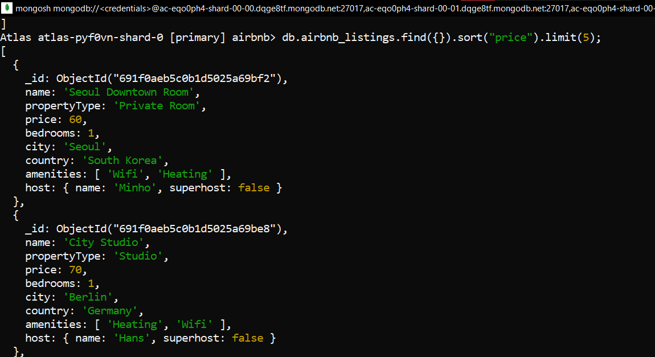

- Sort listings by country → city → price, and display the name, city, and price.
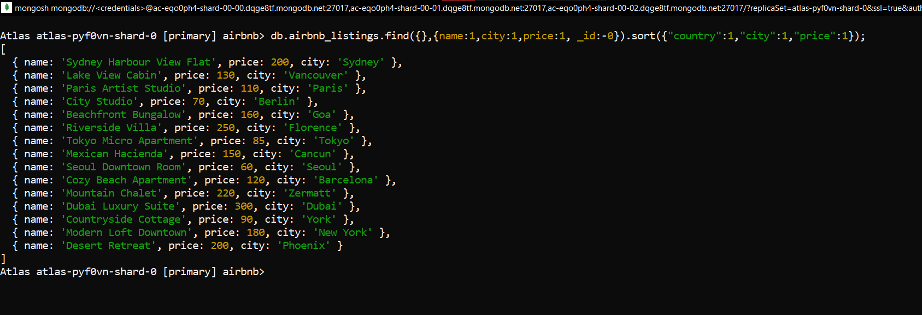

- Show listings from record 11 to 20 (use skip and limit).
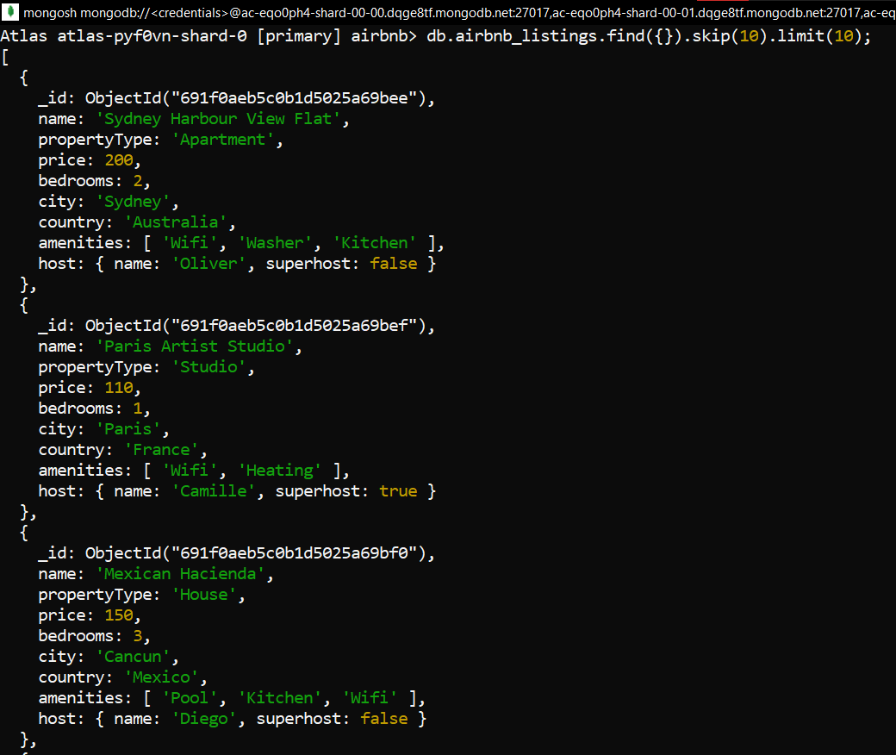

- Add a new field verified: true to the listing with a specific _id (choose any one).
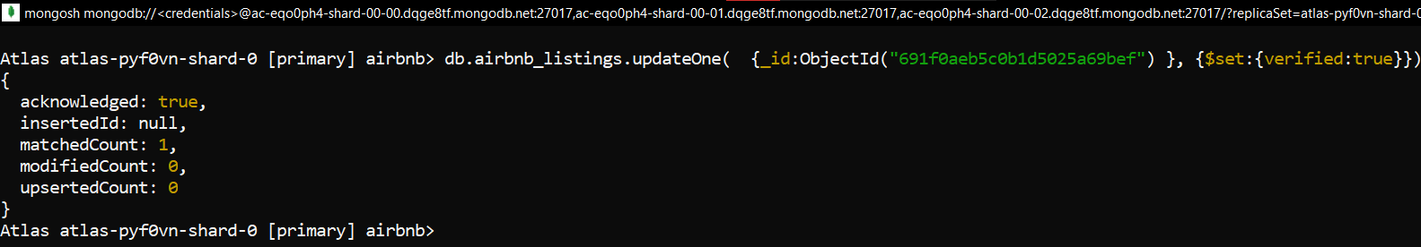

- Update the price of any listing to a new value.
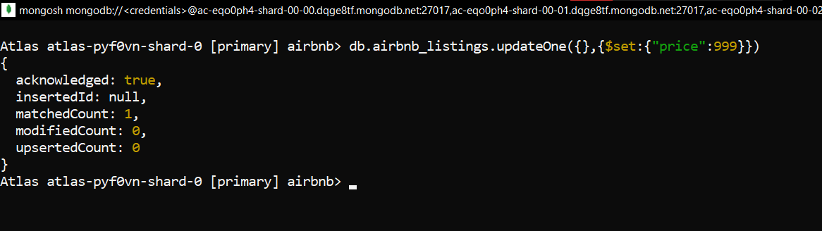

- For all listings in Barcelona, add a field popular: true.
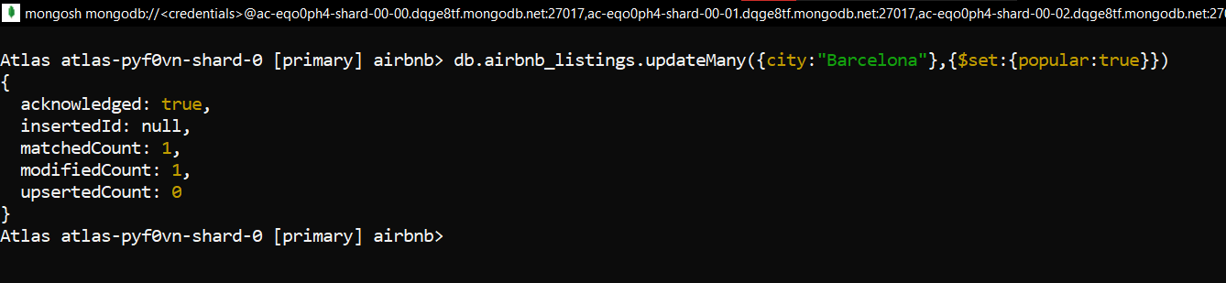

- Remove the field superhost from the host document of any listing.
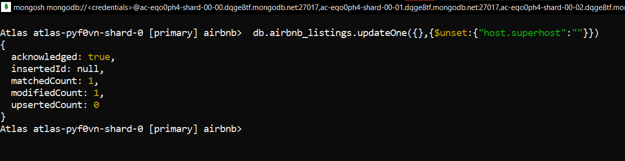

- Rename the field address.market to address.city for all listings.
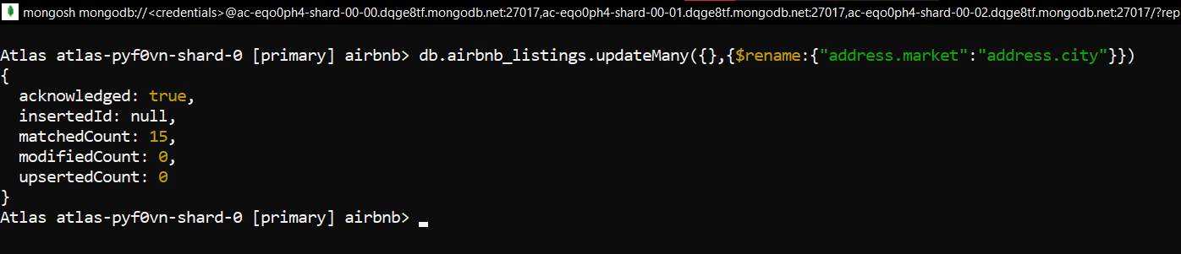
- Remove the first listing whose price is greater than 500.
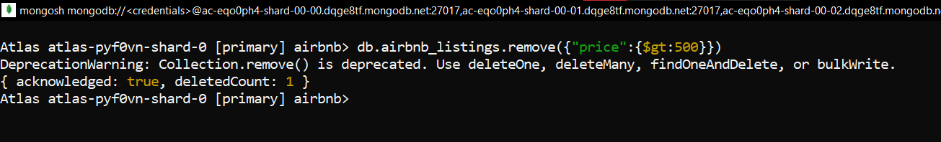

- Remove all listings where the number of bedrooms is 0
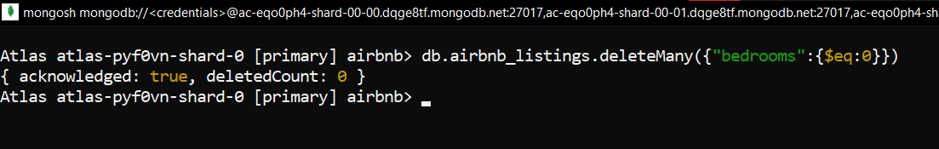

- Drop the entire collection airbnb_listings.
